Deployment Manual

Project Name: Library Management System

Team Members:

1. Indian Bittu
2. Adhithya KR
3. Silpa ER
4. Sudarshan Reddy H
5. Koppolu Harsha Vardhan Reddy

GitHub Detail:

GitHub Link: https://github.com/ib321/Library_Management_System.git

Passwords Used:

1. Oracle Database Credentials:

- Username= SYSTEM
- Password= ib123

2. Application Default Login Credentials:

- Username= Admin
- Password= Admin

- Username= ib123
- Password= ib

Port Numbers used in Application:

- Spring Boot Application Tomcat Server Port Number = 8098

- Angular Application Port Number = 4200

Angular Application Main Application Run Link:

- Link = http://localhost:4200
Steps To Add Project in local work Space from GitHub Using Git Bash:

- Download git 

- Create Folder in workspace

- Open git bash

- Copy workspace Folder Path

5.Use cd command Then Paste the workspace path
$ cd C:/Library_Management_System

6. Copy Link of GitHub Code then in Git Bash use git clone and paste the link
$ git clone https://github.com/ib321/Library_Management_System.git

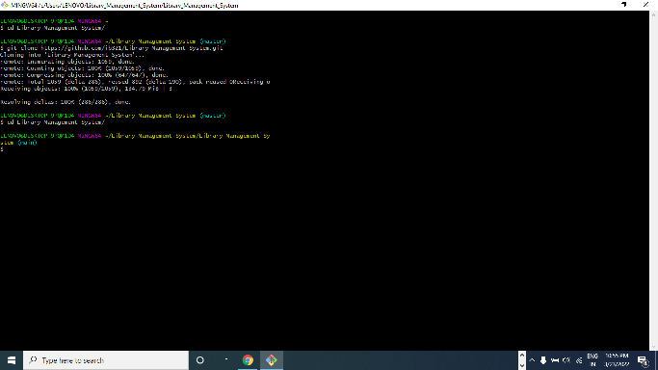

7. Open Eclipse

8. Go to File Menu Choose “Open project from File System”
Open Folder Path of cloned GitHub Java Project

9. Press Next and Finish Importing Library_Management_System project on eclipse

10. Right click on project Name
Go to Run as 1. Maven clean ( then press F5 to refresh)

2. Maven build enter [ goals=clean install ]

11. Go to com.lib package then open Main Class @SpringBootApplication

12. Right click and Run As “Java Application”

Maven Clean:

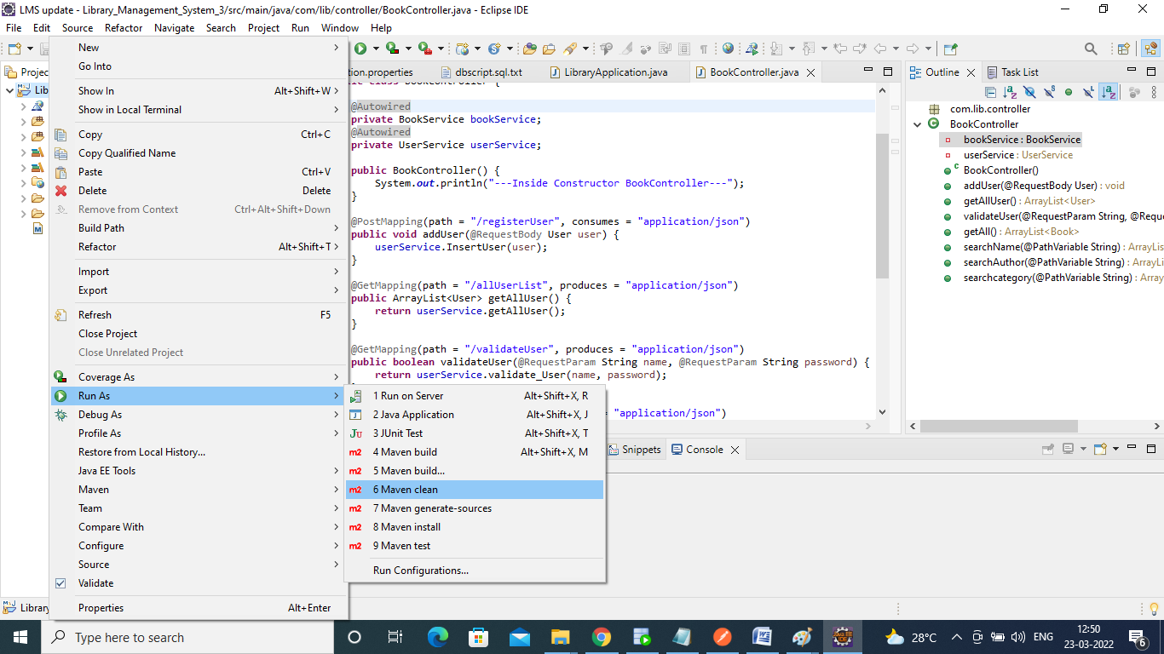

Maven Clean Success:

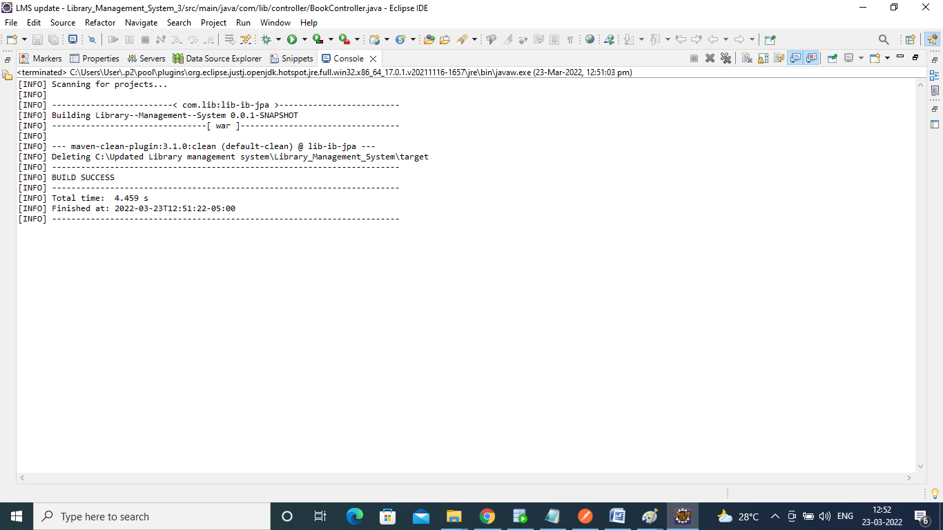

Refresh:

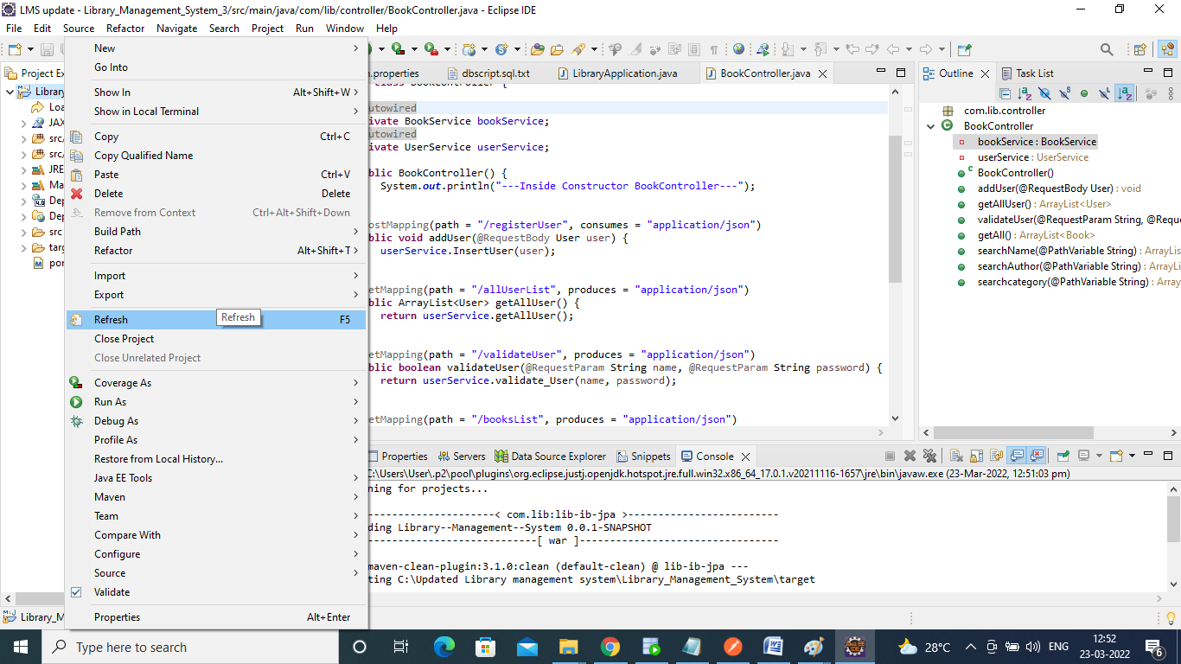

Maven Build:

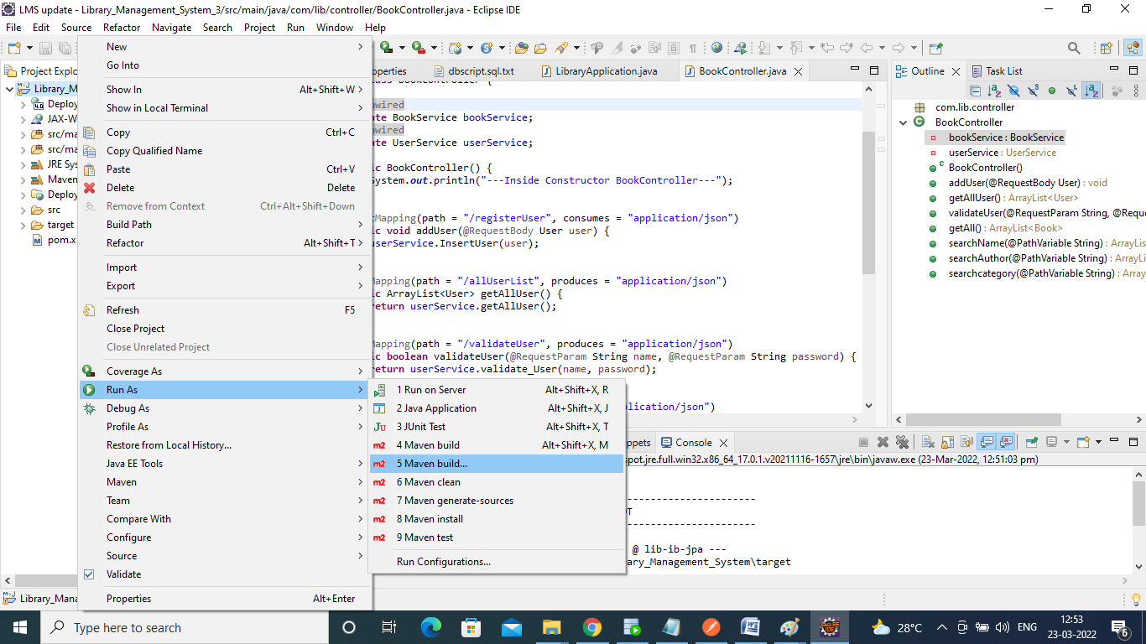

Give Goals: “clean install” Apply then Run:

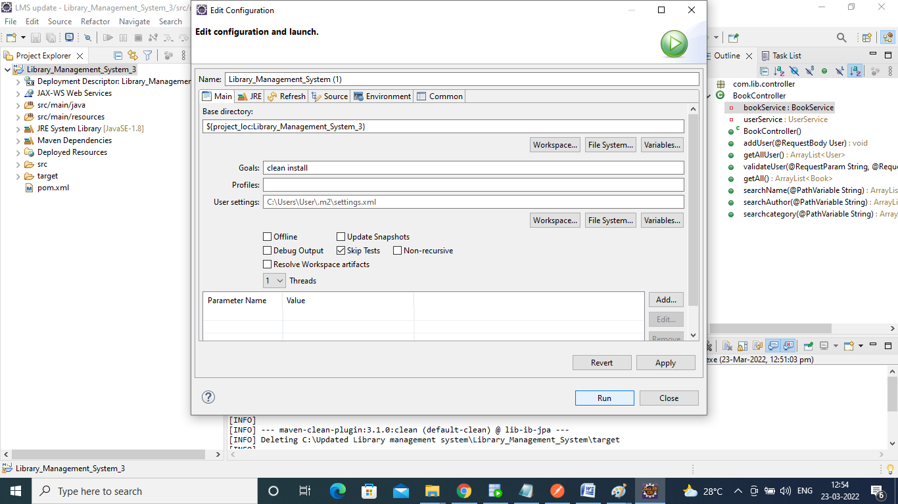

Maven Build success:

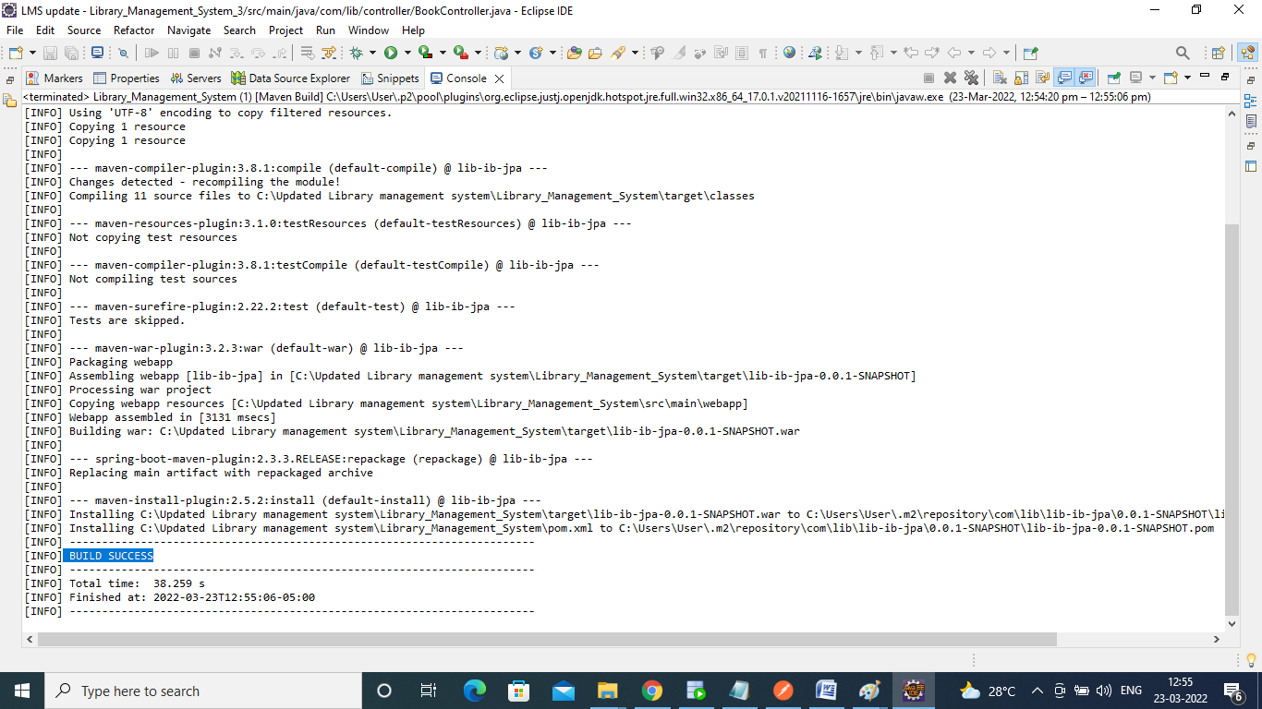

Data Base:

- We have to Download Oracle 11g and SQL developer
- Then we can create tables Book, User

GitHub link for the Database script:

- GitHub Link for the Book Script:

https://github.com/ib321/Library_Management_System/blob/main/DataBase%20Script/book.sql

- GitHub project link for User script:

https://github.com/ib321/Library_Management_System/blob/main/DataBase%20Script/user.sql

Create tables:

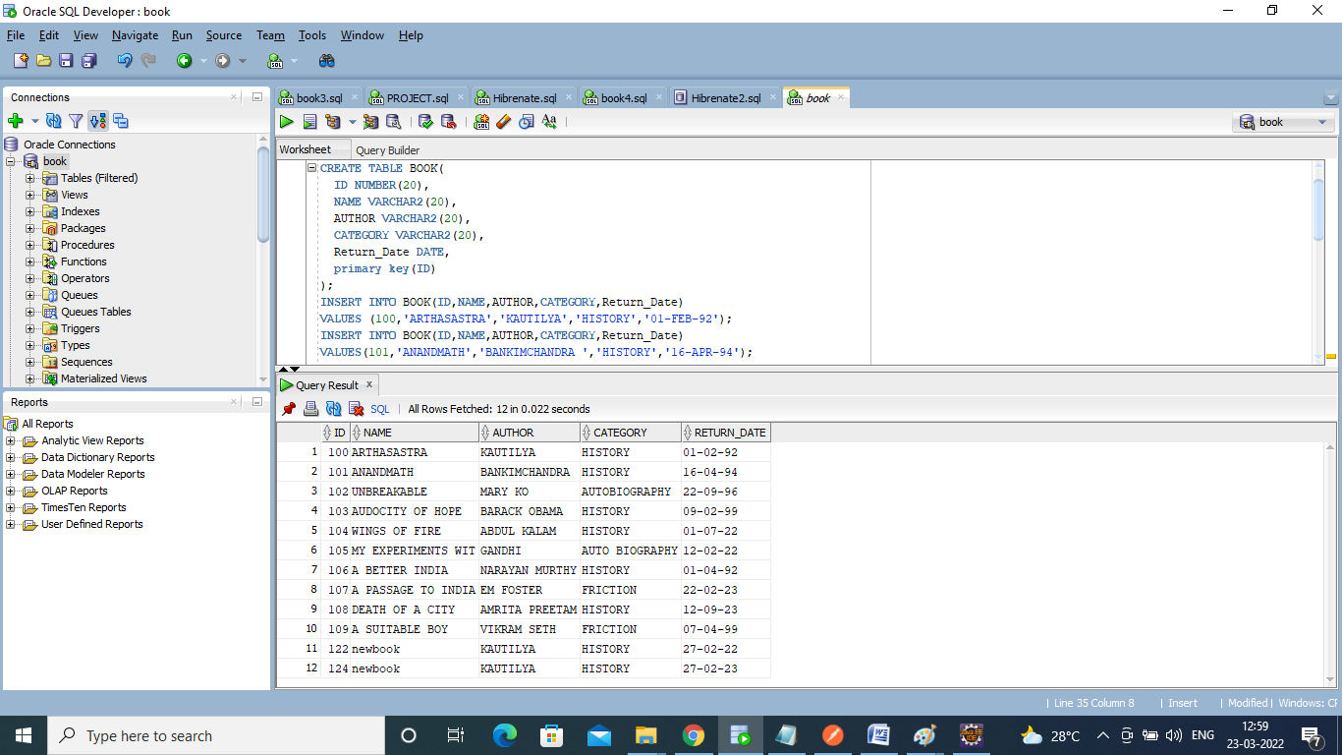

Angular Js:

- First, we download

- Download and install Node.js (including NPM) in windows system
https://nodejs.org/en/download/

- Go to Command Prompt

- Command to check the Node.js version installed in system: node -v

- Install the Angular CLI: npm install -g @angular/cli

- Command to check Angular version installed in your system: ng –version

- Create an Angular Application: ng new libraryApplication
- Go to GitHub Cloned Folder and copy the library application src folder
- Replace src folder of new libraryApplication with That

- Change directory to your application using: cd libraryApplication

- Compile and Run the Angular App: ng serve

- Open browser and access the Application using the below URL: http://localhost:4200/

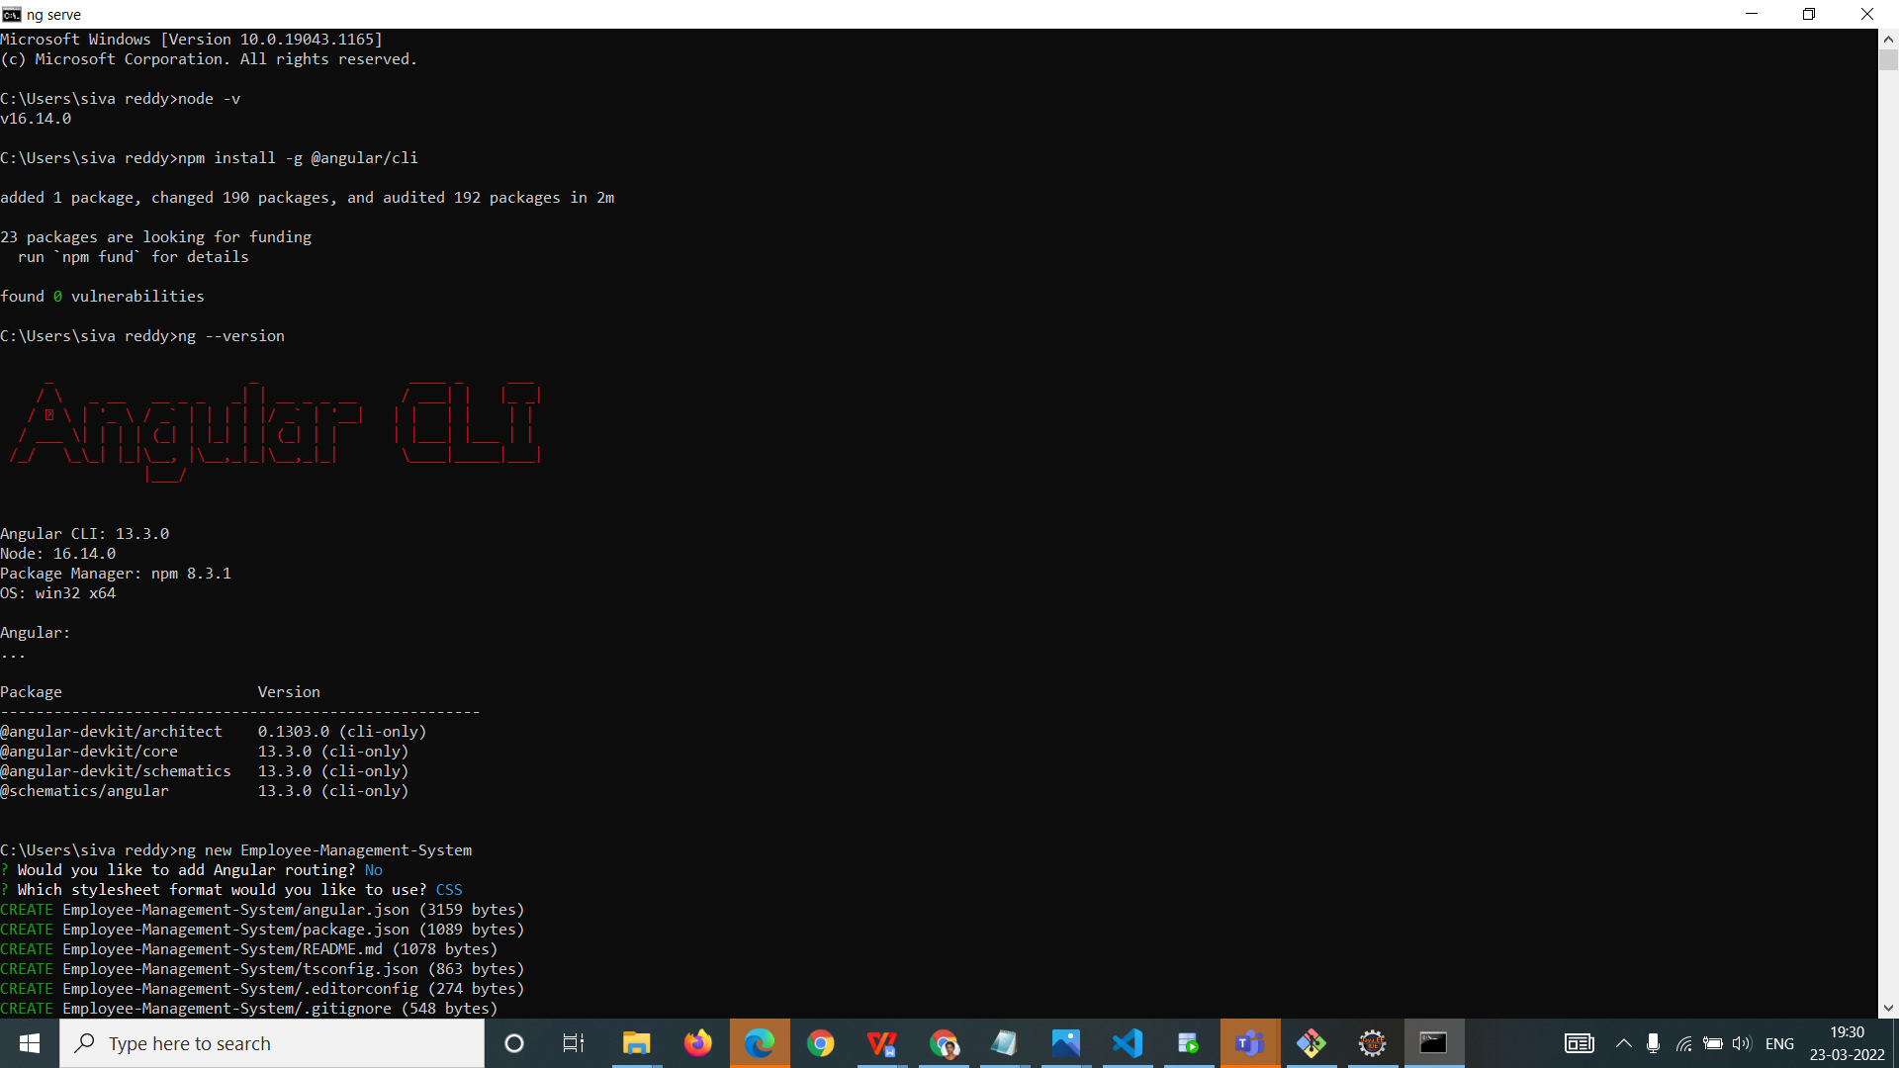

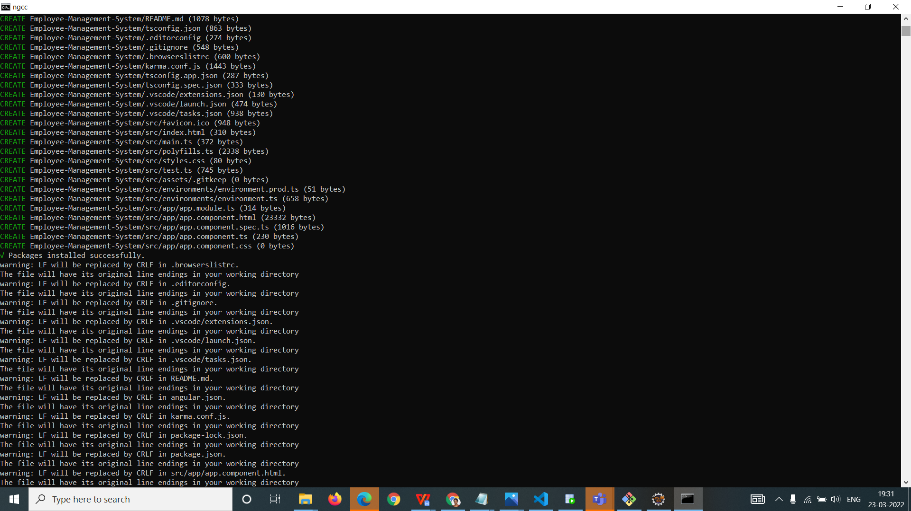
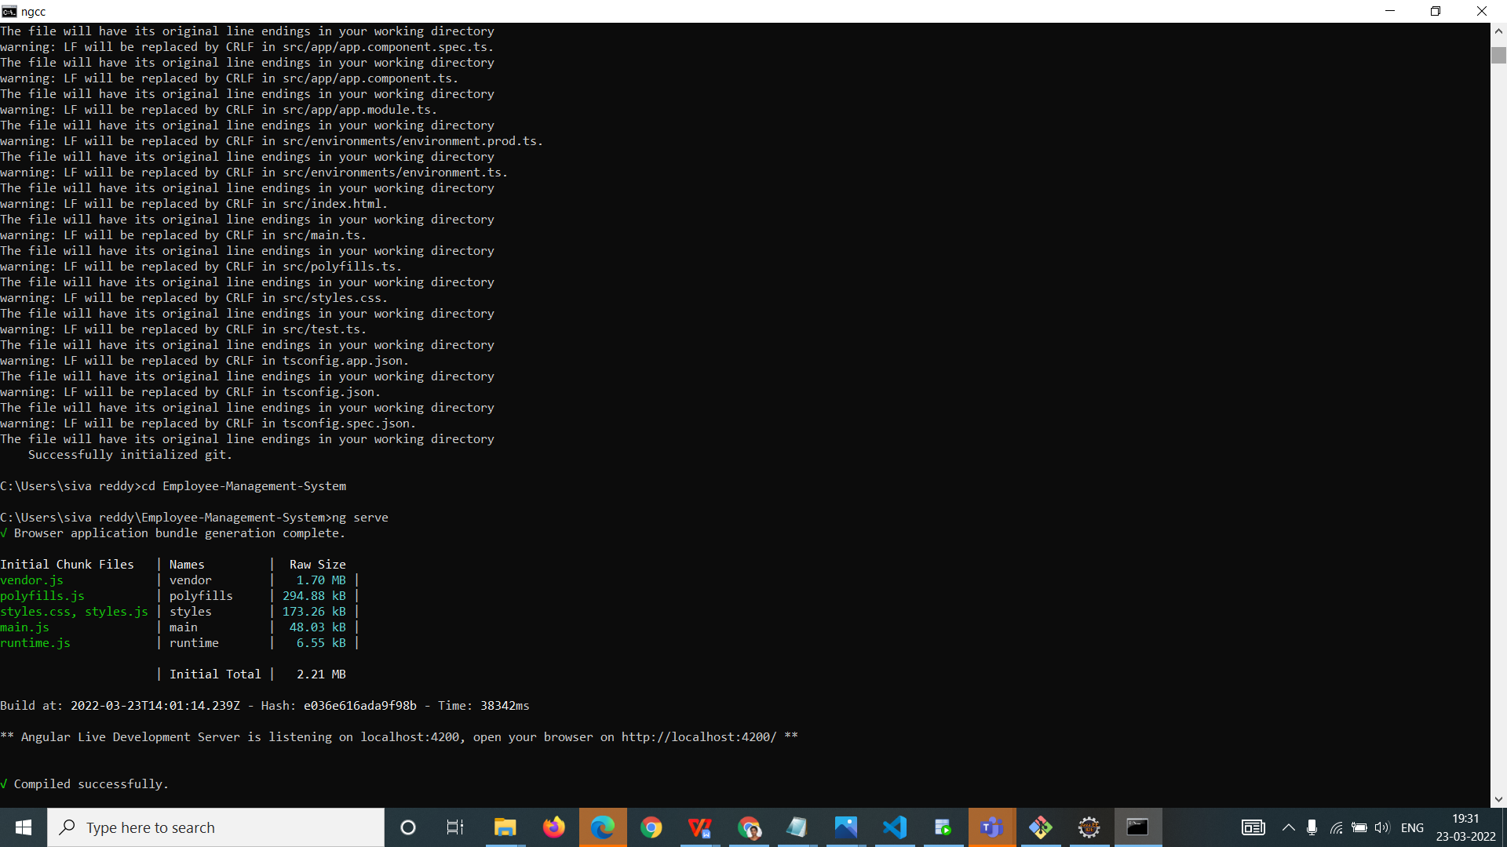

Project Testing / Access:

- Open URL : http://localhost:4200/ from browser
- To login into the application use Default Login Userid and Default Login Password.
- Once you successfully log into the application, you can use the below application functionalities:

- Search by Bookname
- Search by Authorname
- Search by Category

